**Output Screenshots**

1. Welcome Page

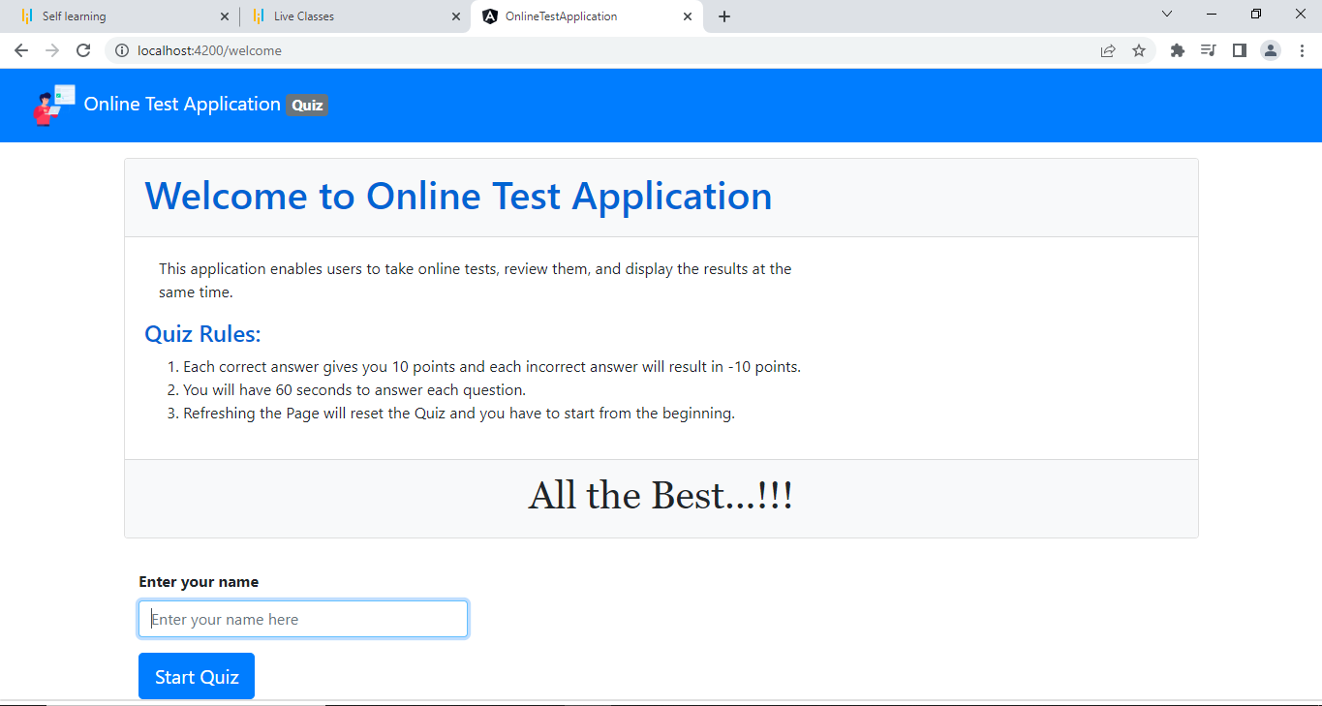

1. Enter your name and click on start quiz

1. Question-1

1. If Correct Answer is selected then it will be highlighted in green and 10 points will be added. (Question 1)

1. If Wrong Answer is selected then it will be highlighted in red and 10 points will be deducted. (Question 2)

1. Question-3

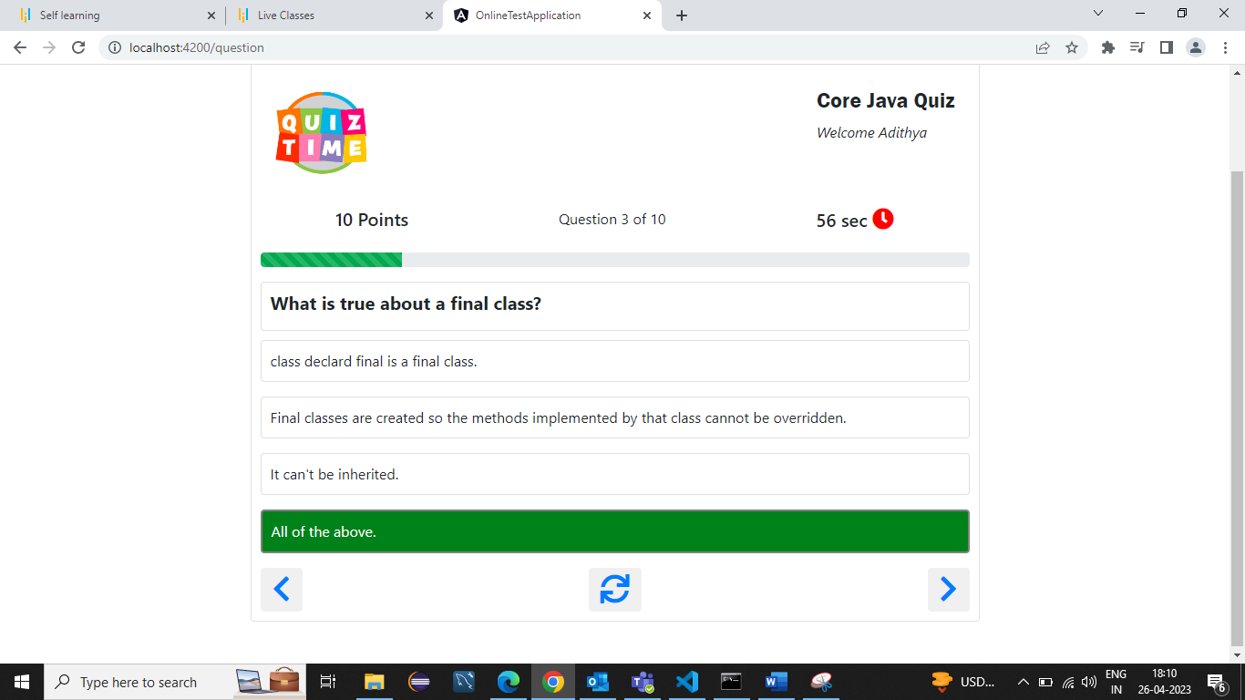

1. Question-4

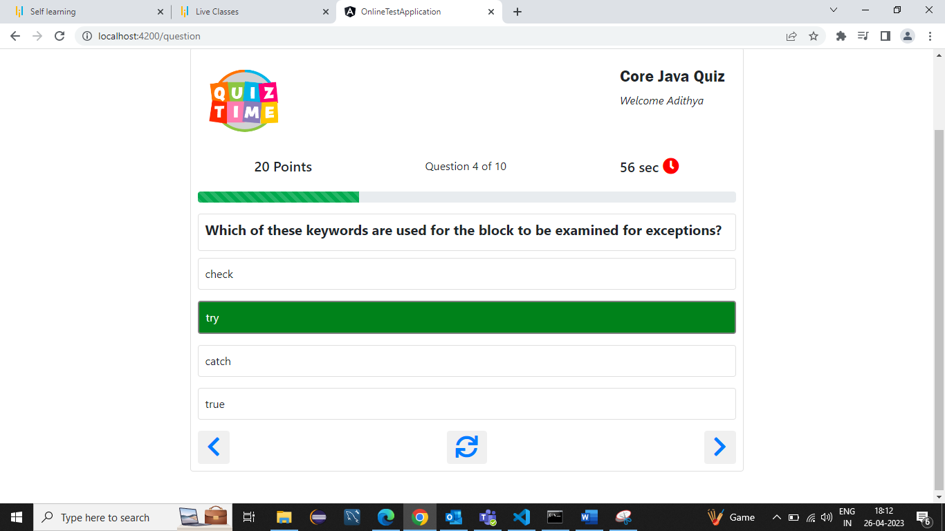

1. Question-5

1. Question-6

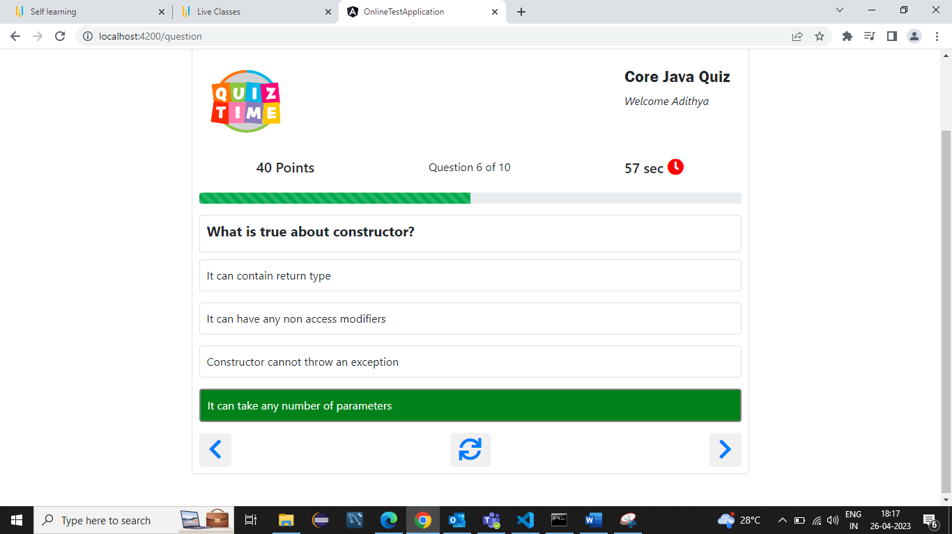

1. Question-7

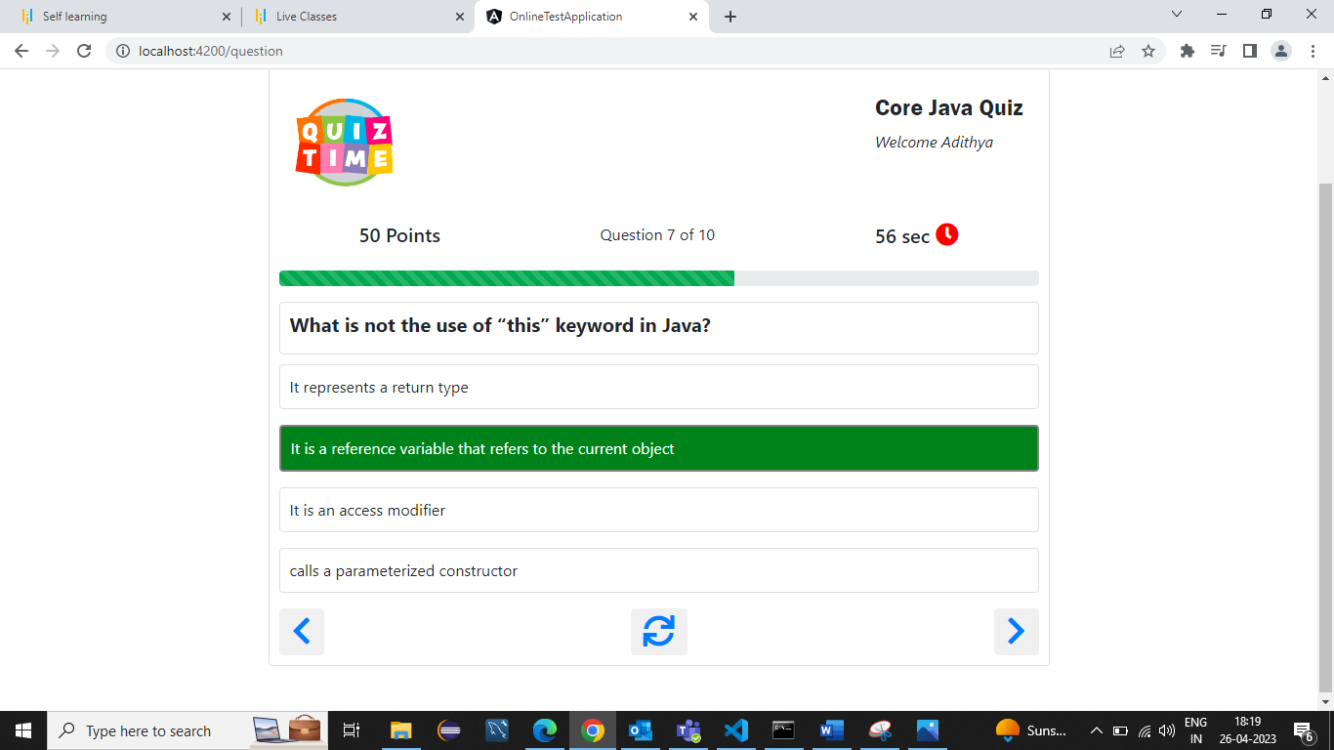

1. Question-8

1. Question-9

1. Question-10

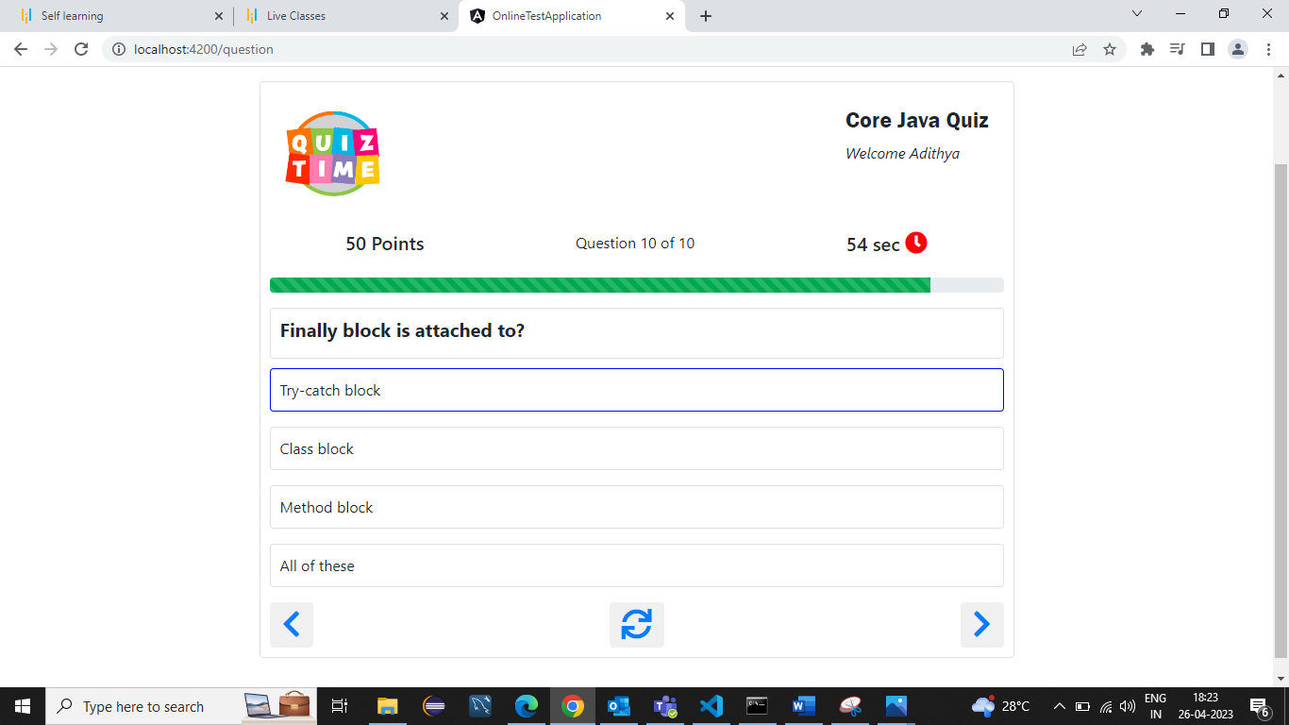

1. Result

1. Review

